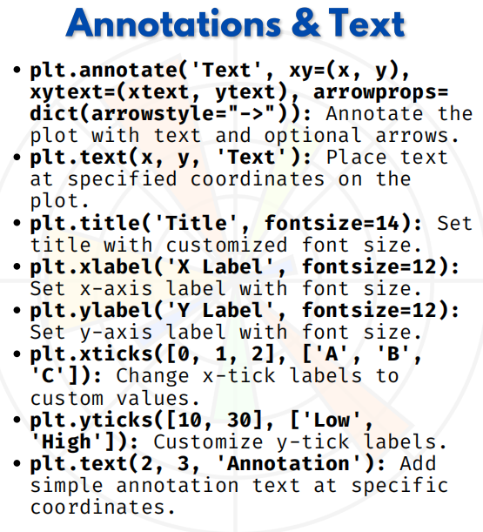

ANNOTATIONS & TEST

Matplotlib: Annotations, Labels & Text
1. plt.annotate()
- Used to add annotations with optional arrows pointing to specific points.
import matplotlib.pyplot as plt
x = [1, 2, 3, 4]
y = [2, 4, 6, 8]
plt.plot(x, y, marker='o')
plt.annotate("Important Point", xy=(2, 4), xytext=(3, 6),
arrowprops=dict(arrowstyle="->"))
plt.show()

2. plt.text()
- Places simple text at given coordinates.
plt.plot([1, 2, 3], [2, 4, 6])
plt.text(2, 4, "Mid Point")
plt.show()

3. plt.title()
- Sets a title for the plot, with optional font size.
plt.plot([1, 2, 3], [2, 4, 6])
plt.title("My First Plot", fontsize=14)
plt.show()

4. plt.xlabel()
- Sets the label for the x-axis.
plt.plot([1, 2, 3], [2, 4, 6])
plt.xlabel("X Axis", fontsize=12)
plt.show()

5. plt.ylabel()
- Sets the label for the y-axis.
plt.plot([1, 2, 3], [2, 4, 6])
plt.ylabel("Y Axis", fontsize=12)
plt.show()

6. plt.xticks()
- Customizes the tick values and labels on the x-axis.
plt.plot([0, 1, 2], [10, 20, 30])
plt.xticks([0, 1, 2], ['A', 'B', 'C'])
plt.show()

7. plt.yticks()
- Customizes the tick values and labels on the y-axis.
plt.plot([1, 2, 3], [10, 20, 30])
plt.yticks([10, 30], ['Low', 'High'])
plt.show()

8. Simple Annotation using plt.text()
- Adding basic annotation text inside the plot.
plt.plot([1, 2, 3], [2, 3, 5])
plt.text(2, 3, "Annotation")
plt.show()

